Concept Document

Group 2

Finn Habraken

Niray Mak

Dary van Sleeuwen

Nidhi Sharma

Edgaras Spiridonovas

Gijs Zwegers

# Version history

|  |  |  |  |
| --- | --- | --- | --- |
| Version | Date | Author | Changes |
| 1.0 | 15-05-2020 | Whole team |  |

Table of contents

**Version history** **2**

**Introduction** **4**

**Brainstorm session** **5**

**Idea** **6**

# 

# Introduction

This project is assigned to us for educational purposes by Fontys.

Our client Olha Bondarenko who is working for township Eindhoven asked us to think about how a mobile application could help solve neighbourhood problems.

There is also a second client whose name is Kees van den Broek. Kees van den Broek created a low code platform. Kees asked us to use his technology to create the application.

The project is realised in the following period: 07-05-2020 till 02-07-2020.

# Brainstorm session

The brainstorming method we used was mind mapping. We first came up with our own ideas of what we think the application should have. Then using this method we came up with some features we want to have in the app.

Mind Map:

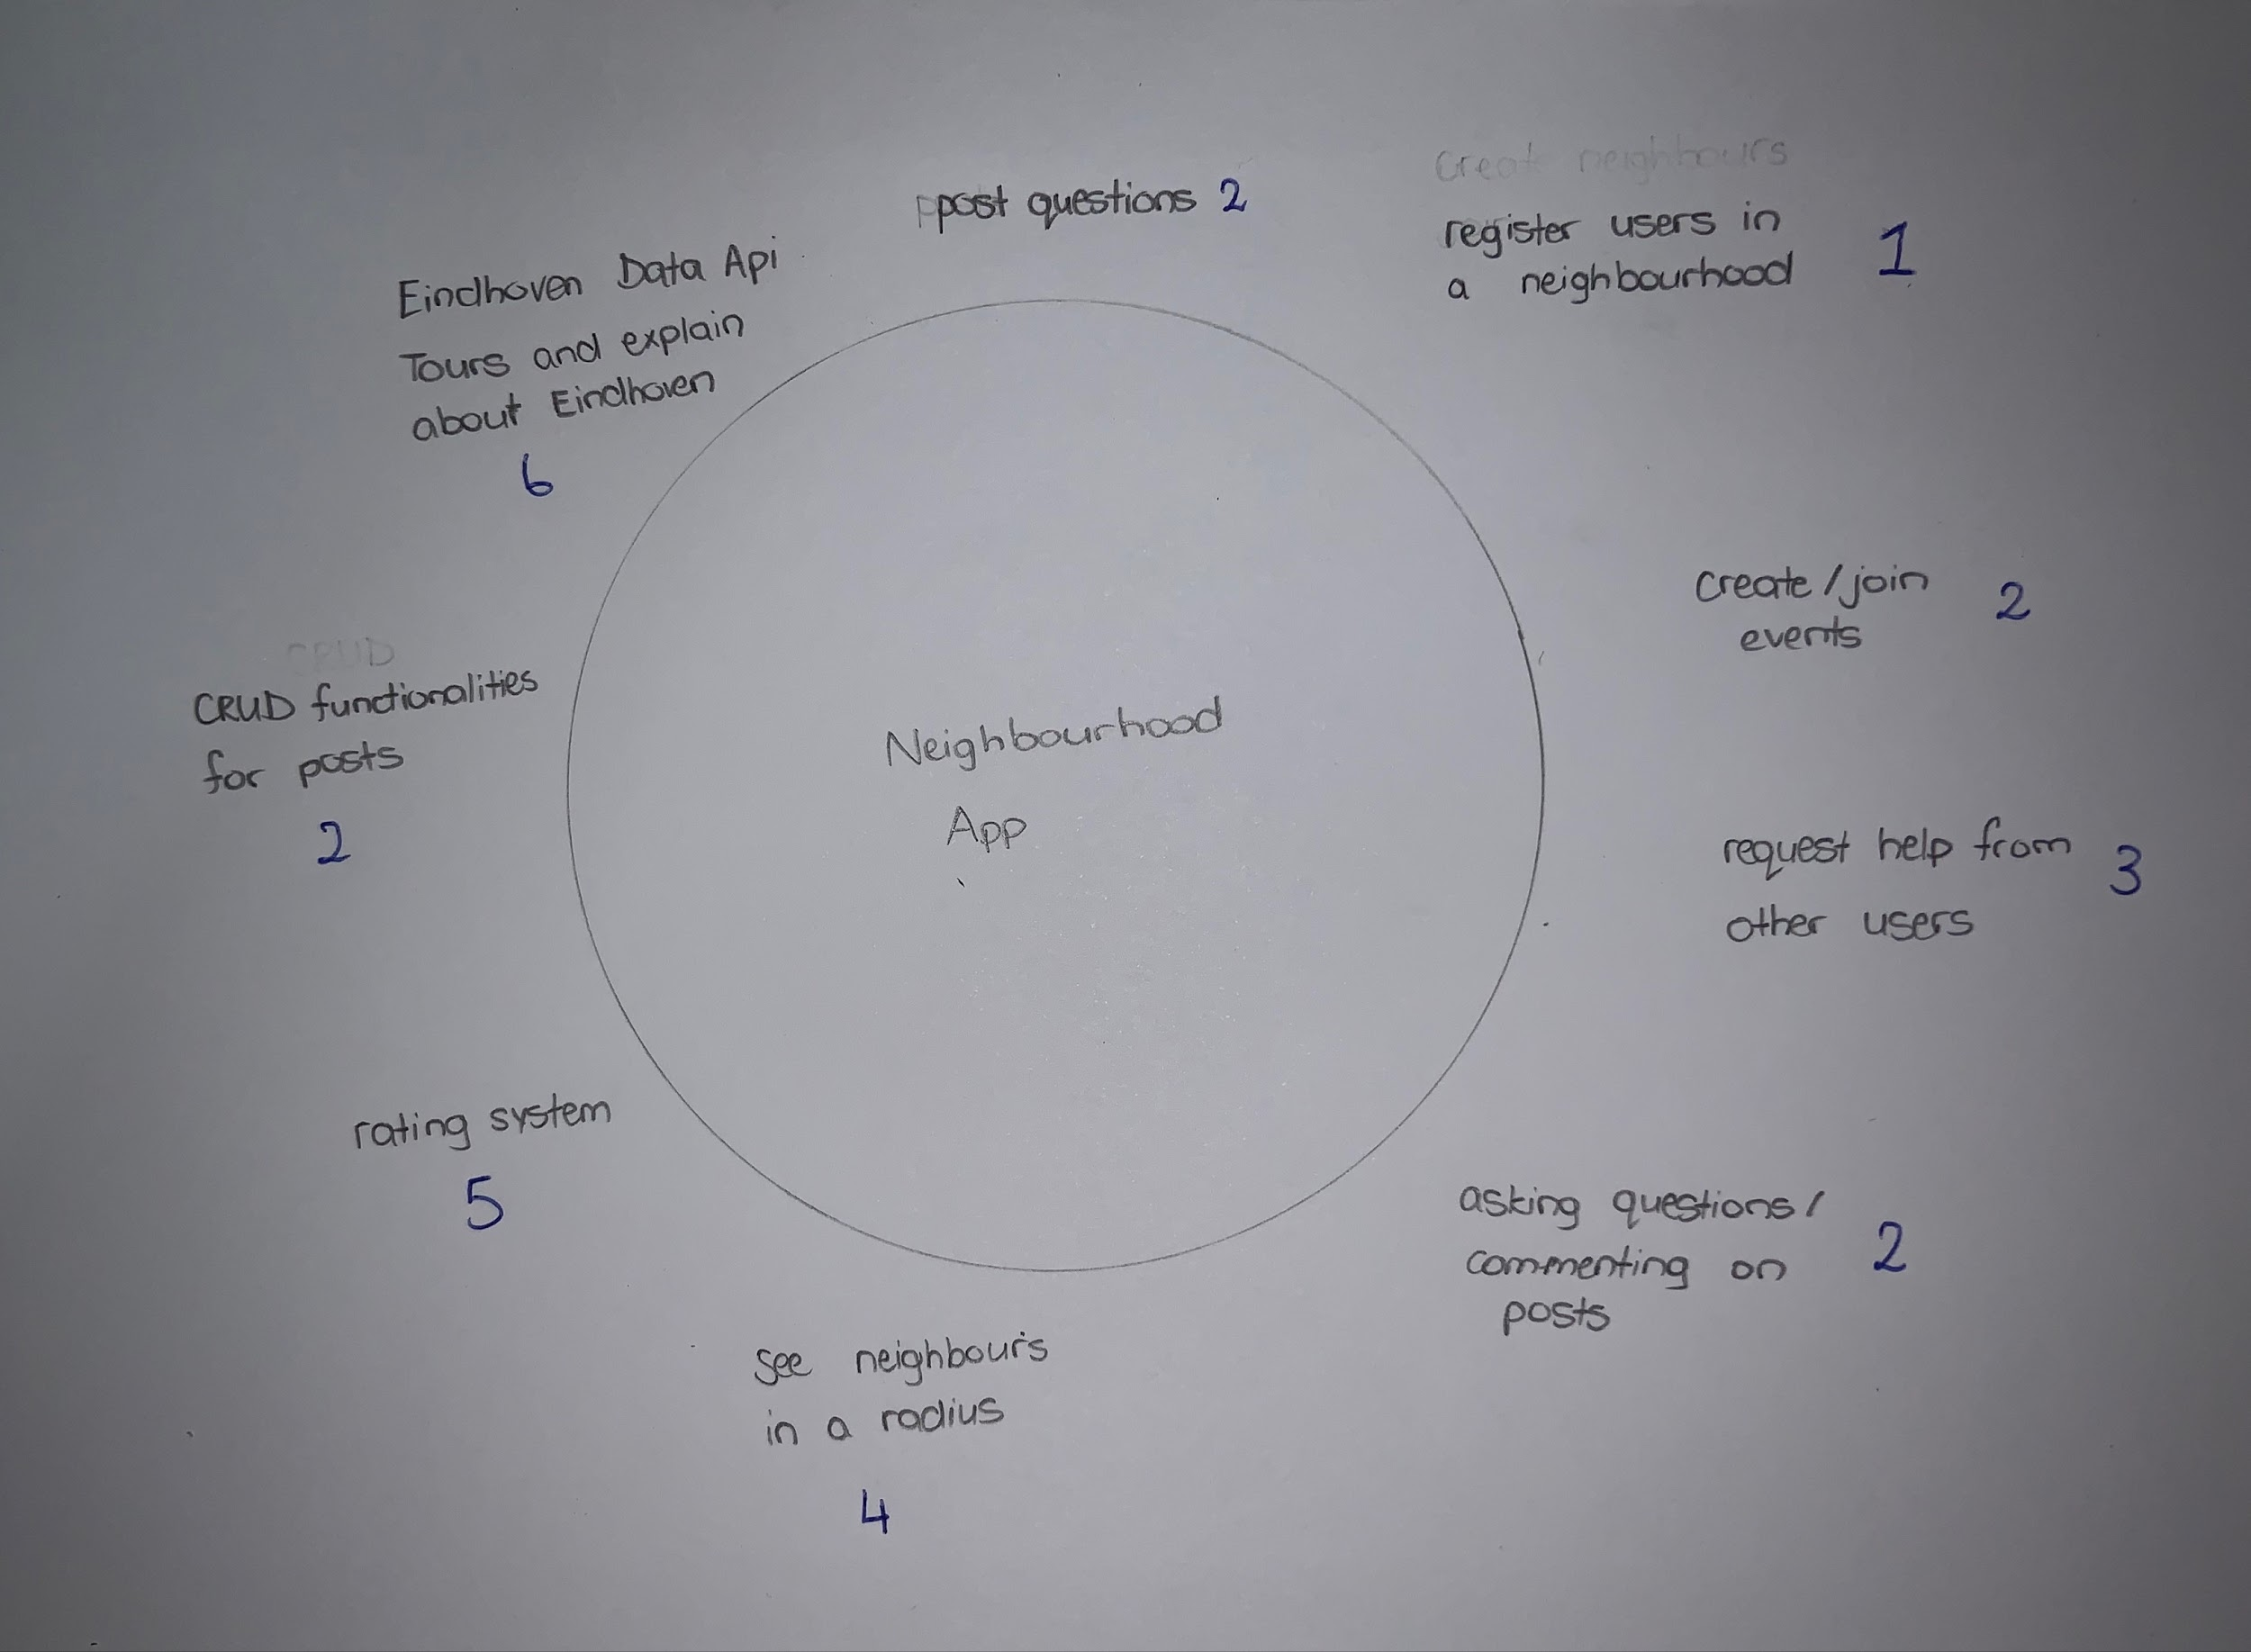

# 

# 

# 

# Idea

We would like to make an application where users can register themselves in a neighbourhood and get to know their neighbours better. In this app, users can create or join events with others. They can request help by asking questions or commenting on posts. In addition, there will be CRUD functionalities for the posts. When the users register they mention their information and say how long they are living in that neighbourhood which helps other users as well.

We are also thinking of extra features for the app which will be optional incase we have a shortage of time: You can see the neighbours in a radius of 500m-2km and which countries they belong to. We would be using no sql storage for the users events and posts for the backend. Moreover, we are thinking of having a rating system, where you can rate people based on how helpful they have been for creating events or answering the questions.

We could make use of Eindhoven data API’s (<https://data.eindhoven.nl/explore/?sort=modified>).

There is a dataset which provides all different buildings in Eindhoven with description. We could use this dataset to create a tour in Eindhoven. Perhaps it would be possible for an experienced habitant to do the tour together and explain stuff about Eindhoven.

API for choosing neighborhood (<https://data.eindhoven.nl/explore/dataset/buurten-naar-wijgebieden/table/?sort=buurtnaam>)

This app would help people from different backgrounds communicate with each other and they can learn about each other’s culture.

We also looked at Next Door and specifically at the weak spots of the app. For example you can’t translate the text of a post and on top of that you can’t copy that text to translate it let's say with Google Translate. So you have to manually type that text in which can take up some time. Also the app is used mostly for posting lost cats which is not the main purpose of that app. We are going to have an event section especially for created events and being able to join them this way we prevent posts that don't serve the purpose of bringing people in the neighborhood together.

**ANSWERS TO OLHA**

1. Which problem would the app be solving?

* Language barrier - being able to change the language of posts chosen by the user (you can translate them without retyping it in google translate).
* Different cultures - providing some essential tips of what you should and shouldn’t do at the event when communicating with people depending on the country they come from.
* Getting to know your neighbours - making events (meetup for picnics, sport activities or other fun things to do).

2. For which user group would the solution be relevant?

* People who are new in the neighbourhood and want to meet their neighbours.
* People who are lonely and would like to make friends.

3. Could you specify it in more detail, maybe in a form of a user story or a scenario?

You are new in your neighbourhood and you want to go play some basketball that is near your home, but there is no one playing or you don't know anyone around your neighbourhood. Then you can download our app.

You can check and see if there are any sport events already or you could make one and if there is someone who likes to play basketball or is interested in the event can join with selecting one of the provided times. Then you meet up at that time, play basketball and get to know each other, possibly you can do it again next time. At the end of the day you at least know one person in your neighbourhood and have someone you can play basketball with.

4. Relate your application to some existing apps that are already used by neighborhoods, such as Next Door, Facebook pages or Whatsapp groups.

We checked the Next Door App and found some disadvantages:

* It’s not possible to change the language of posts (neither copy them).
* Most posts that are used are for missing cats and we’re not sure it’s not the purpose of the app.
* In order to register yourself, you have to wait and receive a post in your mail which takes a while and we don't think that is necessary.
* The posts are not categorized and they cannot be sorted.

We checked the Facebook App and found some disadvantages:

* There are way too many people and you can't really see how many neighbours are near you and you would need to make a lot of groups.
* Facebook is not used mostly by Dutch people.

We checked the Whatsapp App and found some disadvantages:

* Just like facebook you would need a lot of groups and to make the groups you would need each person’s number.
* If someone suggests something and other people continue talking in the group chat, things might be overlooked.
* People are able to miss someone's offer to meet up because of the same problem and it would take a lot of time to discuss who is available and see how many people would actually join.

5. Which added value would your app have compared to these solutions?

* You are able to translate posts.
* Getting some important tips of cultural differences based on people's backgrounds at that event.
* Events section with categories to be able to see what events are interesting enough for you (sports, picnics, etc).
* Setting radius around you and see how many neighbours are registered and from which country they belong to. (That way you could get an idea how many people around you are registered and where they come from. This will give you an idea of how much people can expect at the event.